Hulsebus Chiropractic Clinic
1010 Harlem Road • Machesney Park, IL 61115
815.654.1044
Child Case History

Patient Information
Name: __________________________________________________________ (Age) _________ Gender: M F
Home Address: ___________________________________________________ Birth Date: ____/_____ /______
City, State, Zip: ___________________________________________________ Cell Phone: ( ) _____________________

Name of Mother/Guardian: _________________________________________ Home Phone: ( ) __________________
Birth Date: ____ /____ /_____ (Age) ________ Marital Status: S M D W Work Phone: ( ) ___________________
Home Address (if different): _________________________________________ Cell Phone: ( ) _____________________
City, State, Zip: ___________________________________________________ Email: _______________________________
Employer Name: __________________________________________________ Occupation: __________________________

Name of Father/Guardian: __________________________________________ Home Phone: ( ) ___________________
Birth Date: ____/____ /____ (Age) ________ Marital Status: S M D W Work Phone: ( ) ___________________
Home Address (if different): _________________________________________ Cell Phone: ( ) ____________________
City, State, Zip: ___________________________________________________ Email: ______________________________
Employer Name: __________________________________________________ Occupation: _________________________

How were you referred to this office? ______________________________________________________________________
Have you seen a chiropractor before? Yes / No
Purpose for This Visit
Reason for this visit: ____________________________________________________________________________________
Is this related to an accident or specific injury (other than auto or work-related)*? Yes / No If yes, when: ____ /____ /_____
*If your child’s symptoms are the result of an auto accident or work-related injury, please ask the front-desk for the corresponding application.
Describe incident or reason for onset of symptoms: ___________________________________________________________
Please use the General Symptoms Chart on the next page to provide a detailed notation of your child’s symptoms.
When did these symptoms begin? ____/ ____/____ Are they: Constant Intermittent Activity-related
Are they getting worse? Yes / No Do they interfere with: School Sleep Hobbies/Play Daily Routine
Explain: _______________________________________________________________________________________________
What activities aggravate these symptoms? __________________________________________________________________
Is there anything that relieves your symptoms? Yes / No If yes, explain: _______________________________________
Has your child experienced these symptoms before (if not accident/injury related)? Yes / No
If yes, explain: __________________________________________________________________________________________
Has your child been treated for this? Yes / No When was the last treatment? ____/ ____/____
Name of treating practitioner/facility? _______________________________________________________________________
What treatment(s) was performed? _________________________________________________________________________
How did your child respond? _______________________________________________________________________________

GENERAL SYMPTOMS CHART

Please use the following notations on the figures below to indicate the type and location
of your symptoms, as it relates to the purpose of your visit today.

A = ACHE G = STABBING N = NUMBNESS
B = BURNING M = SPASMS T = TINGLING
P = PINS & NEEDLES F = STIFFNESS O = OTHER

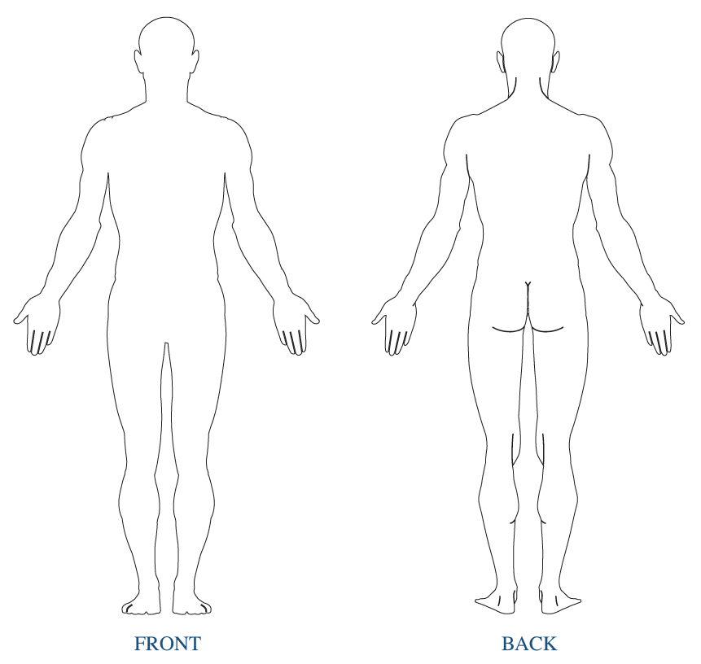
HISTORY OF TRAUMA
The below-listed traumas may lead to misalignment of the individual vertebrae, soft tissue injury to the supportive structures of the
spine, as well as shifts and distortions in whole curves and sections of the spine. Please check any of the following if your child has
experienced such (if you check an item with an asterisk, please offer a detailed explanation):

____ Fell from a height of two (2) feet or more as an infant
____ Experienced a fall that left a bruise or lump on their head or other resulting trauma*
____ Rough shaking as an infant
____ Were involved in a car accident (if you check this item, please ask the front desk person for the corresponding form)
____ Experience broken bones or debilitating injuries*
____ Difficult Birth (see below)
Explanation of (*) item(s): ________________________________________________________________________________
Birth Experience:
How long was labor? ____________________________________________________________________________________
Describe any complications: ______________________________________________________________________________
Type of delivery: Vaginal C-Section Vacuum Extraction Forceps Assistance
Health Conditions
Your spine is the foundation of health and core strength in your body. Shifts in the vertebrae or sections of the spine will spread
ultimately causing weakness and distortion to ALL the areas of the spine. These distortions are reflected in abnormal posture. Research shows abnormal posture leads to chronic pain, disease and possibly a shortened life span. Please answer the following questions accurately so we may determine the full extent of your child’s condition.

Cervical Spine (Neck)
Misalignment of the individual vertebrae or distortion of the complete cervical curve (neck) originating in the neck or a compensation from postural distortions in other areas of the spine may result in many health conditions. Has your child experienced any of these symptoms presently or in the past?

Please indicate (N) = Now, (P) = Past next to all conditions you’ve experienced or both if applicable.

____ Neck Pain ____ Headaches ____ Sinusitis
____ Pain in shoulders/arms/hands ____ Dizziness ____ Allergies/Hay fever
____ Numbness/tingling in arms/hands ____ Visual disturbances ____ Re-current colds/Flu
____ Hearing disturbances ____ Coldness in hands ____ Low Energy/Fatigue
____ Weakness in grip ____ Thyroid conditions ____ Colic
____ Ear Infections ____ Flu/Stomach disorders ____ Sore throats
____ Learning disabilities ____ Hyperactivity/ADD ____ Auto-Immune Diseases
____ Other (please explain)

Thoracic Spine
Misalignment of the individual vertebrae or distortion of the upper thoracic curve originating in the upper back or a compensation from postural distortions in other areas of the spine may result in many health conditions. Has your child experienced
any of these symptoms presently or in the past?

Please indicate (N) = Now, (P) = Past next to all conditions you’ve experienced or both if applicable.

____ Heart Palpitations ____ Heart Murmurs ____ Asthma/Wheezing ____ Shingles
____ Shortness Of Breath ____ Upper Back Pain ____ Pain On Deep Inspiration/Expiration
____ Recurrent Lung Infections/Bronchitis/Pneumonia ____ Mid Back Pain ____ Nausea
____ Diabetes ____ Pain in Ribs/Chest ____ Ulcers/Gastritis ____ Reflux
____ Diabetes ____ Liver problems ____ Spleen problems ____ Other (please explain)
LUMBAR Spine (Low Back)
Misalignment of the individual vertebrae or distortion of the lumbar curve (low back) originating in the low back or compensation from postural distortions in other areas of the spine may result in many health conditions. Have you experienced any of these symptoms presently or in the past?

Please indicate (N) = Now, (P) = Past next to all conditions you’ve experienced or both if applicable.
____ Low back pain ____ Pain in hips/legs/feet ____ Weakness/injuries in hips/knees/ankles
____ Numbness/tingling in legs/feet ____ Coldness in legs/feet ____ Muscle cramps in legs/feet
____ Frequent/difficulty urinating ____ Constipation/Diarrhea ____ Menstrual irregularities/cramping

OTHER
Have you ever been hospitalized? Yes/ No
Please list any surgeries (include type of surgery and date it was performed): ___________________________________
__________________________________________________________________________________________________
__________________________________________________________________________________________________

Pregnancy Release
This is to certify that to the best of my knowledge I am not pregnant and the above doctor and his associates have my permission to perform an x-ray evaluation. Yes / No

Consent to Treat a Minor
I hereby authorize the doctor and/or his designated staff to administer chiropractic care as deemed necessary to my ____________________ (indicate relationship of child).
Name of Child: ______________________________________________________
Dated at Machesney Park, IL on this ___________ day of ______________, 20___.
Parent/Guardian Signature: ___________________________________________
Witnessed: ________________________________________________________

