Hulsebus Chiropractic Clinic
1010 Harlem Road • Machesney Park, IL 61115
815.654.1044

Patient Information
Name: ___________________________________________________________ (Age) ______ Gender: M F
Home Address: ____________________________________________________ Home Phone: ( ) ____________
City, State, Zip: ____________________________________________________ Work Phone: ( ) ____________
Email Address: ____________________________________________________ Cell Phone: ( ) ____________
Birth Date: ____/____ /_____ Social Security #: _____ -_____ -_______ Marital Status: S M D W
Occupation: _________________________________________ Employer Name: _______________________________
Spouse’s Name: ___________________________ Work Phone: ( ) _____________ Cell Phone: ( ) _______________
Spouse’s Employer: ________________________________________ Occupation: ___________________________________
How were you referred to this office? ________________________________________________________________________
Have you seen a Chiropractor before? Yes / No

Purpose for This Visit
Reason for this visit: ______________________________________________________________________________________
Is this related to an accident or specific injury (other than auto or work-related)*? Yes / No If yes, when: ____ /____ /_____
*If your symptoms are the result of an auto accident or work-related injury, please ask the front-desk for the corresponding application.
Describe: ______________________________________________________________________________________________
Please use the General Symptoms Chart on the next page to provide a detailed notation of your symptoms.
When did these symptoms begin? ____/____ /_____ Are they: Constant Intermittent Activity-related
Are they getting worse? Yes / No Do they interfere with: Work Sleep Hobbies Daily Routine
Explain: _______________________________________________________________________________________________
What activities aggravate your symptoms? ___________________________________________________________________
Is there anything that relieves your symptoms? Yes / No If yes, explain: ___________________________________________
Have you experienced these symptoms before (if not accident/injury related)? Yes/ No
If yes, explain: __________________________________________________________________________________________
Have you been treated for this? Yes / No When were you last treated? ____/ ____ /____
Who did you see? _______________________________________________________________________________________
What treatment was performed? __________________________________________________________________________
How did you respond? ___________________________________________________________________________________

Health & Lifestyle
Do you exercise? Yes / No How often? _____ day(s) per week; Other: _____________________________________
What activities? Walking Running/Jogging Weight Training Cycling Yoga Pilates Swimming Other: __________
Do you smoke? Yes / No How much? / How often? ____________________________________________
Do you drink alcohol? Yes / No How much? / How often? ____________________________________________
Do you drink coffee? Yes / No How much? / How often? ____________________________________________
Do you take any supplements (i.e. vitamins, minerals, herbs)? ___________________________________________________
If yes, please list: _______________________________________________________________________________________

GENERAL SYMPTOMS CHART

Please use the following notations on the figures below to indicate the type and location
of your symptoms, as it relates to the purpose of your visit today.

A = ACHE
B = BURNING
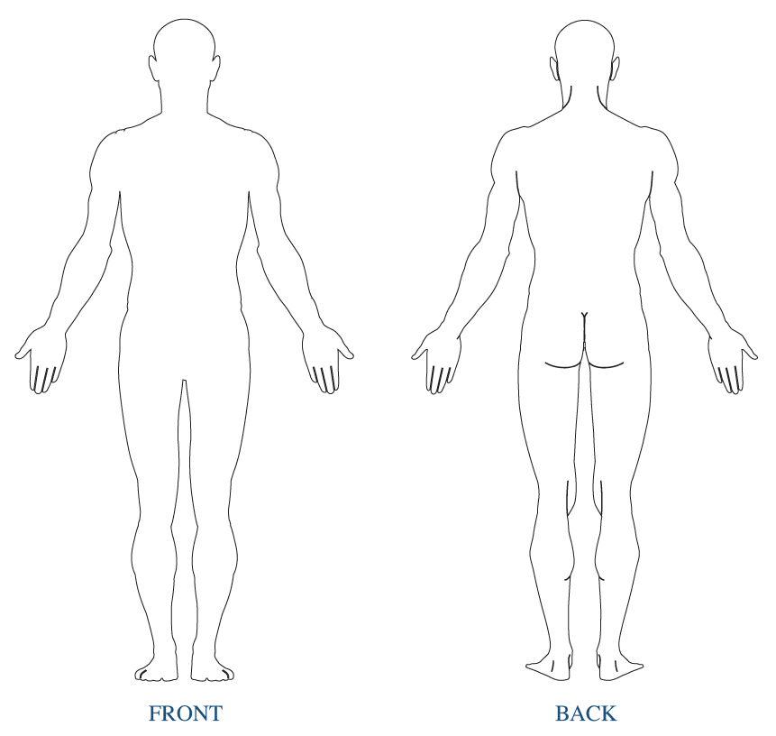
P = PINS & NEEDLES
G = STABBING
M = SPASMS
F = STIFFNESS
N = NUMBNESS
T = TINGLING

Health Conditions
Your spine is the foundation of health and core strength in your body. Shifts in the vertebrae or sections of the spine will spread ultimately causing weakness and distortion to ALL the areas of the spine. These distortions are reflected in abnormal posture. Research shows abnormal posture leads to chronic pain, disease and possibly a shortened life span. Please answer the following questions accurately so we may determine the full extent of your condition.

CERVICAL SPINE (Neck)
Misalignment of the individual vertebrae or distortion of the complete cervical curve (neck) originating in the neck or a compensation from postural distortions in other areas of the spine may result in many health conditions. Have you experienced any of these symptoms presently or in the past?

Please indicate (N) = Now, (P) = Past next to all conditions you’ve experienced or both if applicable.
____ Neck Pain ____ Headaches ____ Sinusitis
____ Pain in shoulders/arms/hands ____ Dizziness ____ Allergies/Hay fever
____ Numbness/tingling in arms/hands ____ Visual disturbances
____ Hearing disturbances ____ Coldness in hands
____ Weakness in grip ____ Thyroid conditions

THORACIC SPINE
Misalignment of the individual vertebrae or distortion of the upper thoracic curve originating in the upper back or a compensation from postural distortions in other areas of the spine may result in many health conditions. Have you experienced any of these symptoms presently or in the past?

Please indicate (N) = Now, (P) = Past next to all conditions you’ve experienced or both if applicable.
____ Mid Back Pain ____ Heart Palpitations ____ Recurrent Lung Infections/Bronchitis
____ Pain in Ribs/Chest ____ Heart Murmurs ____ Asthma/Wheezing
____ Heartburn ____ Heart Attacks/Angina ____ Shortness of Breath
____ Nausea ____ Diabetes ____ Ulcers

LUMBAR SPINE (Low Back)
Misalignment of the individual vertebrae or distortion of the lumbar curve (low back) originating in the low back or compensation from postural distortions in other areas of the spine may result in many health conditions. Have you experienced any of these symptoms presently or in the past?

Please indicate (N) = Now, (P) = Past next to all conditions you’ve experienced or both if applicable.
____ Low back pain ____ Pain in hips/legs/feet ____ Weakness/injuries in hips/knees/ankles
____ Numbness/tingling in legs/feet ____ Coldness in legs/feet ____ Muscle cramps in legs/feet
____ Frequent/difficulty urinating ____ Constipation/Diarrhea ____ Menstrual irregularities/cramping

OTHER
Have you ever been hospitalized? Yes/ No
Please list any surgeries (include type of surgery and date it was performed): ___________________________________
__________________________________________________________________________________________________
__________________________________________________________________________________________________

Pregnancy Release
This is to certify that to the best of my knowledge I am not pregnant and the above doctor and his associates have my permission to perform an x-ray evaluation. Yes / No

Emergency Contact
Name: _____________________________________ Relationship: _________________________ Phone# _____________________

